

**VS-Code Installation Guide**

1)Visit the Official VS-Code website . Link-<https://code.visualstudio.com/Download>

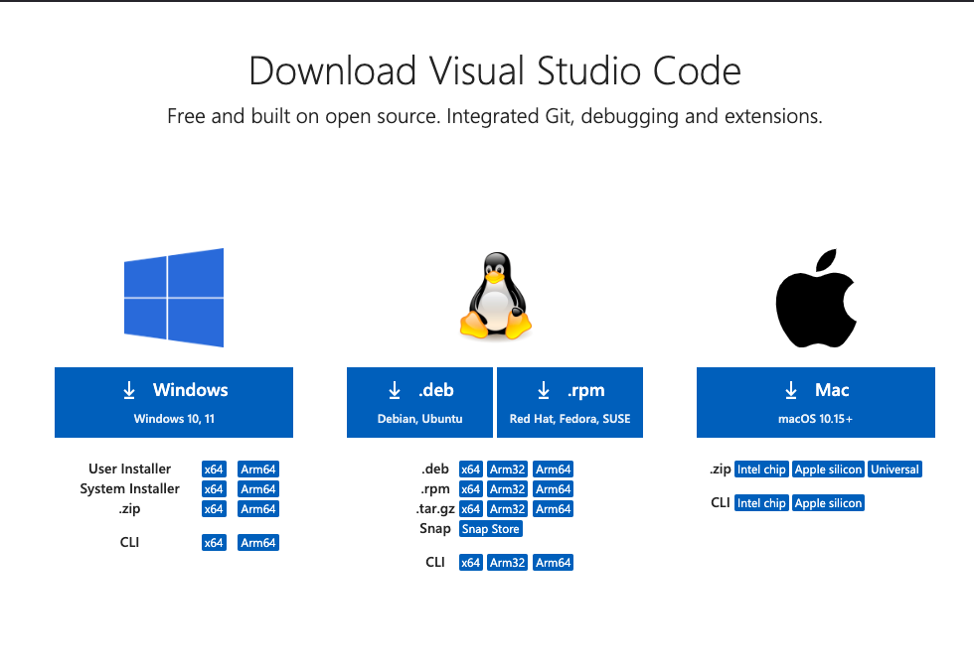

2)Download the VS-Code installer based on your computer's operating system.

3)Once the installer has been downloaded,open it from the downloads folder.

4)Accept the License Agreement to begin the installation.

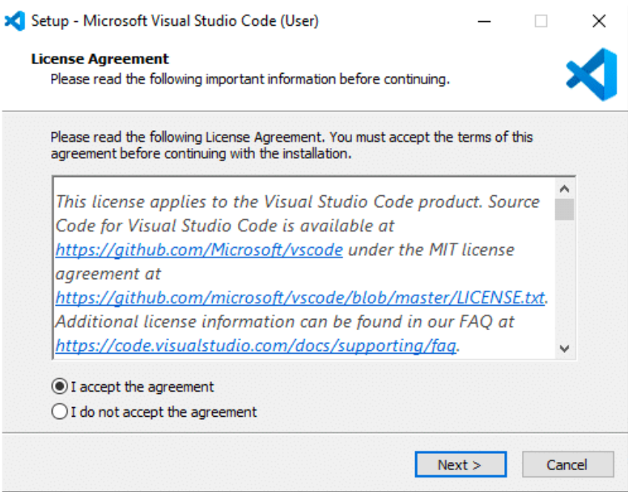

5)After accepting all the requests and agreement,you can choose the location where you would like it to be installed.**“C:\users{username}\AppData\Local\Programs\Microsoft VS Code.”** is the default installation location for Windows.



6)Then the installation will begin and you will be notified once it has been installed.

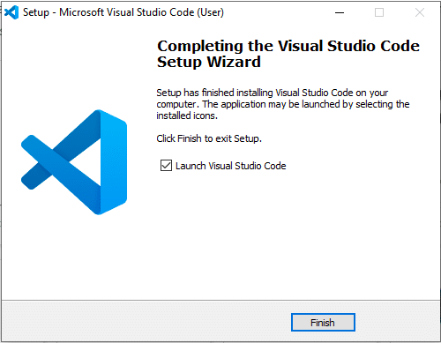

7)VS-Code should launch immediately.If not you can launch VS Code from the Start menu or by searching for "Visual Studio Code" in the search bar.The following window will open.